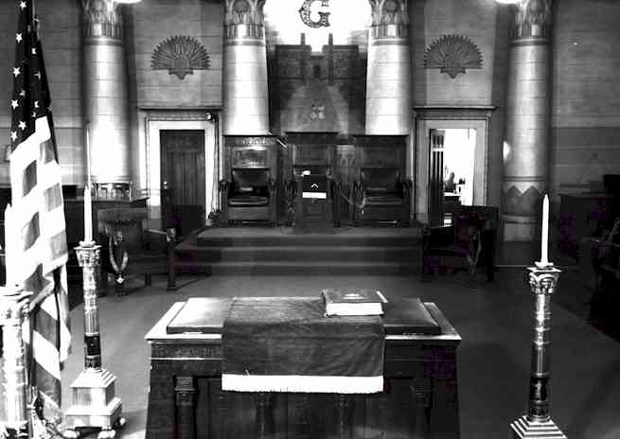
Congratulations Colorado DeMolay
on another successful year.
Good Luck from the
The Brethren of Tejon Lodge #104

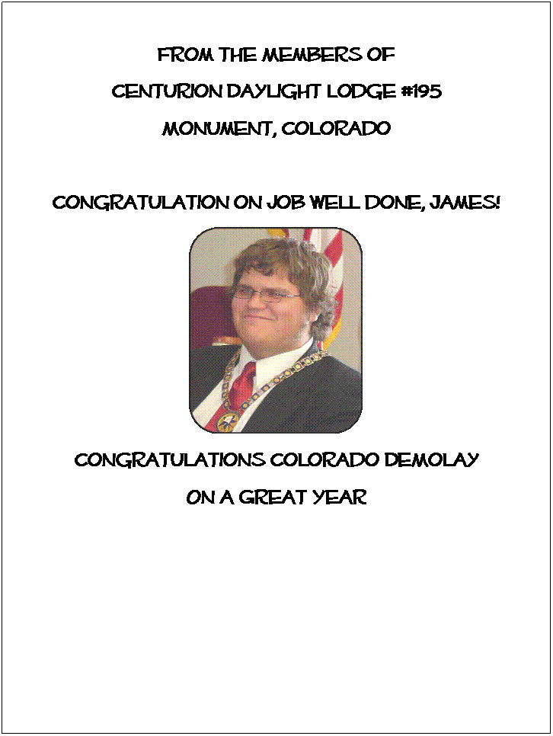

EstesPark Lodge #183

Gatewayto Rocky Mountain National Park

Congratulations
JamesReiter, State Master Councilor
AndColorado DeMolay

Meeting:7:30 p.m.
1st&3rdMonday
DarkJanuary&February

MichaelTracy, WM
1820S. St Vrain Avenue
Telephone:(970)586-8097


