
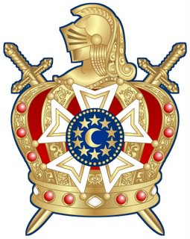
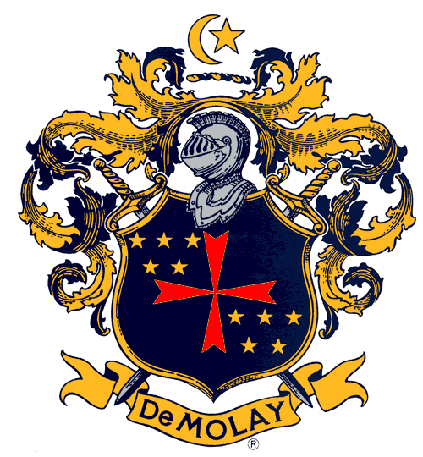

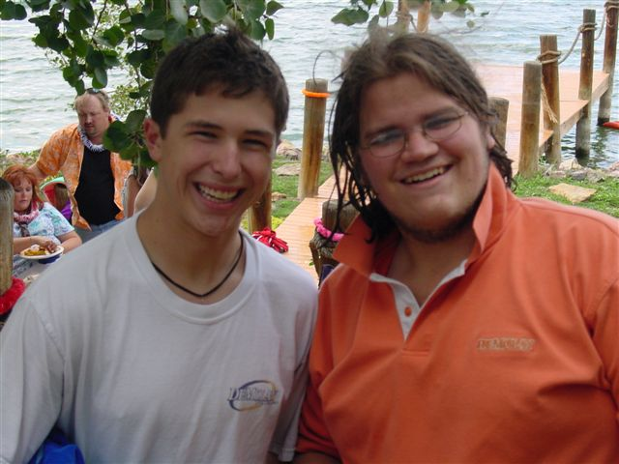
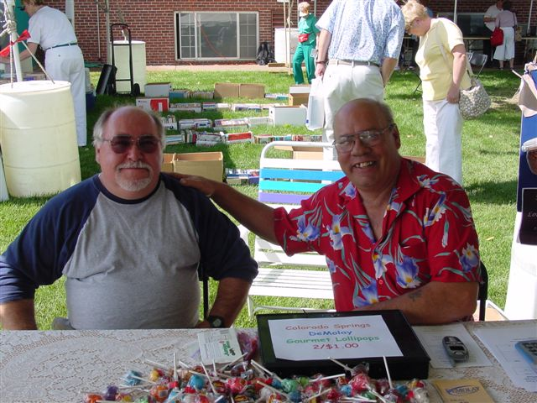
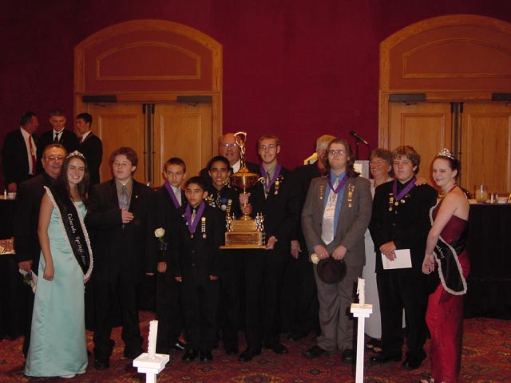
1919
TRADITION,
Order of DeMolay
Colorado Springs Chapter

Visit our website:
http://csdemolay.weebly.com
LEADERSHIP,
TEAMWORK,
CHALLENGE,
FUN & FRIENDSHIP,
SERVICE,
EXCELLENCE!

DeMolay is an organization dedicated to preparing young men to lead successful, happy, and productive lives. Basing its approach on timeless principles and practical, hands-on experience, DeMolay opens doors for young men aged 12 to 21 by developing the civic awareness, personal responsibility and leadership skills so vitally needed in society today.
1150 Panorama Drive, Colorado Springs CO 80904
Join DeMolay Now!
Colorado Springs Chapter Dad
Ben Pilato: 719-434-8085
Email: benpilato@hotmail.com

